Programming Exercise CSV: Student Grade Manager
Pedro Clavero De Dios
March 29, 2026
COP 2373
This program allows an instructor to input student names and three exam grades, then writes the data to a grades.csv file using the csv module. A separate function reads the grades.csv file and displays the data in tabular format. The with keyword is used for file handling.
Function: get_student_data
Prompts the instructor to enter student names and three exam grades for a specified number of students.
Parameters:
None
Variables:
num_students (int): The number of students to enter.
students (list): A list of lists containing each student's data.
first_name (str): The student's first name.
last_name (str): The student's last name.
exam1 (int): The student's first exam grade.
exam2 (int): The student's second exam grade.
exam3 (int): The student's third exam grade.
Logic:
1. Ask the instructor how many students they want to enter.
2. Loop through the number of students.
3. For each student, prompt for first name, last name, and three exam grades.
4. Append each student's data as a list to the students list.
5. Return the list of student data.
Return:
list: A list of lists, each containing first name, last name, and three exam grades.

Function: write_grades_csv
Writes student data to a grades.csv file using the csv module and the with keyword.
Parameters:
students (list): A list of lists containing each student's data.
Variables:
header (list): The header row for the CSV file.
csv_file (file): The file object for grades.csv.
writer (csv.writer): The CSV writer object.
Logic:
1. Define the header row with column names.
2. Open grades.csv for writing using the with keyword.
3. Create a csv.writer object.
4. Write the header row.
5. Write each student's data as a row.
6. Display a confirmation message.
Return:
None

Function: read_grades_csv
Reads the grades.csv file and displays the data in tabular format using the with keyword.
Parameters:
None
Variables:
csv_file (file): The file object for grades.csv.
reader (csv.reader): The CSV reader object.
header (list): The header row from the CSV file.
row (list): A row of student data from the CSV file.
Logic:
1. Check if grades.csv exists.
2. Open grades.csv for reading using the with keyword.
3. Create a csv.reader object.
4. Read the header row and display it formatted.
5. Print a separator line.
6. Read and display each student record in tabular format.
Return:
None

Function: main
Main function that runs the grade management program with a menu loop.
Parameters:
None
Variables:
choice (str): The user's menu selection.
students (list): The list of student data entered by the instructor.
Logic:
1. Display a welcome message.
2. Enter a loop to present a menu to the user.
3. Option 1: Get student data and write to grades.csv.
4. Option 2: Read grades.csv and display in tabular format.
5. Option 3: Exit the program.
6. Repeat until the user chooses to exit.
Return:
None

Screenshot:
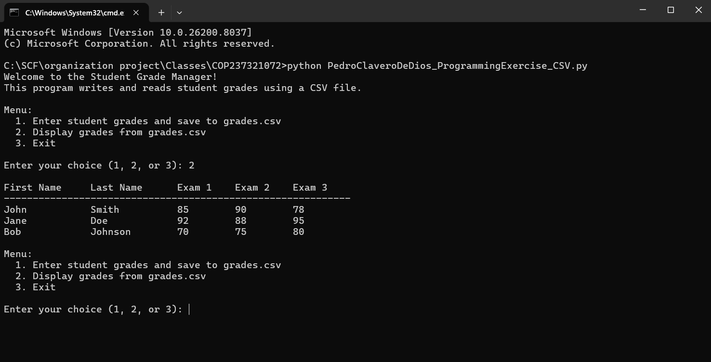
Repo
GitHub Repo Link: https://github.com/Pclav34/PC_COP2373

